**CertificateRegistry.sol – Smart Contract Deployment**

# Deployed by: Nandini Pandey

Date: 09/06/2025  
Source code: [CertificateRegistry.sol](https://github.com/nytrixis/vertects-lab_iit-delhi/blob/master/CertificateRegistry.sol)

**Contract Address:** 0x3C677FBfc8405AB8aFEc1c4dEF1768A975111003

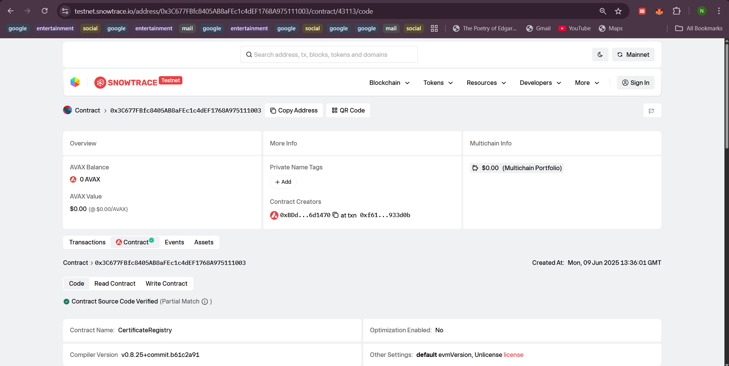

Fig.: Contract verification screenshot

**Snowtrace URL:** https://testnet.snowtrace.io/address/0x3C677FBfc8405AB8aFEc1c4dEF1768A975111003/contract/43113/code